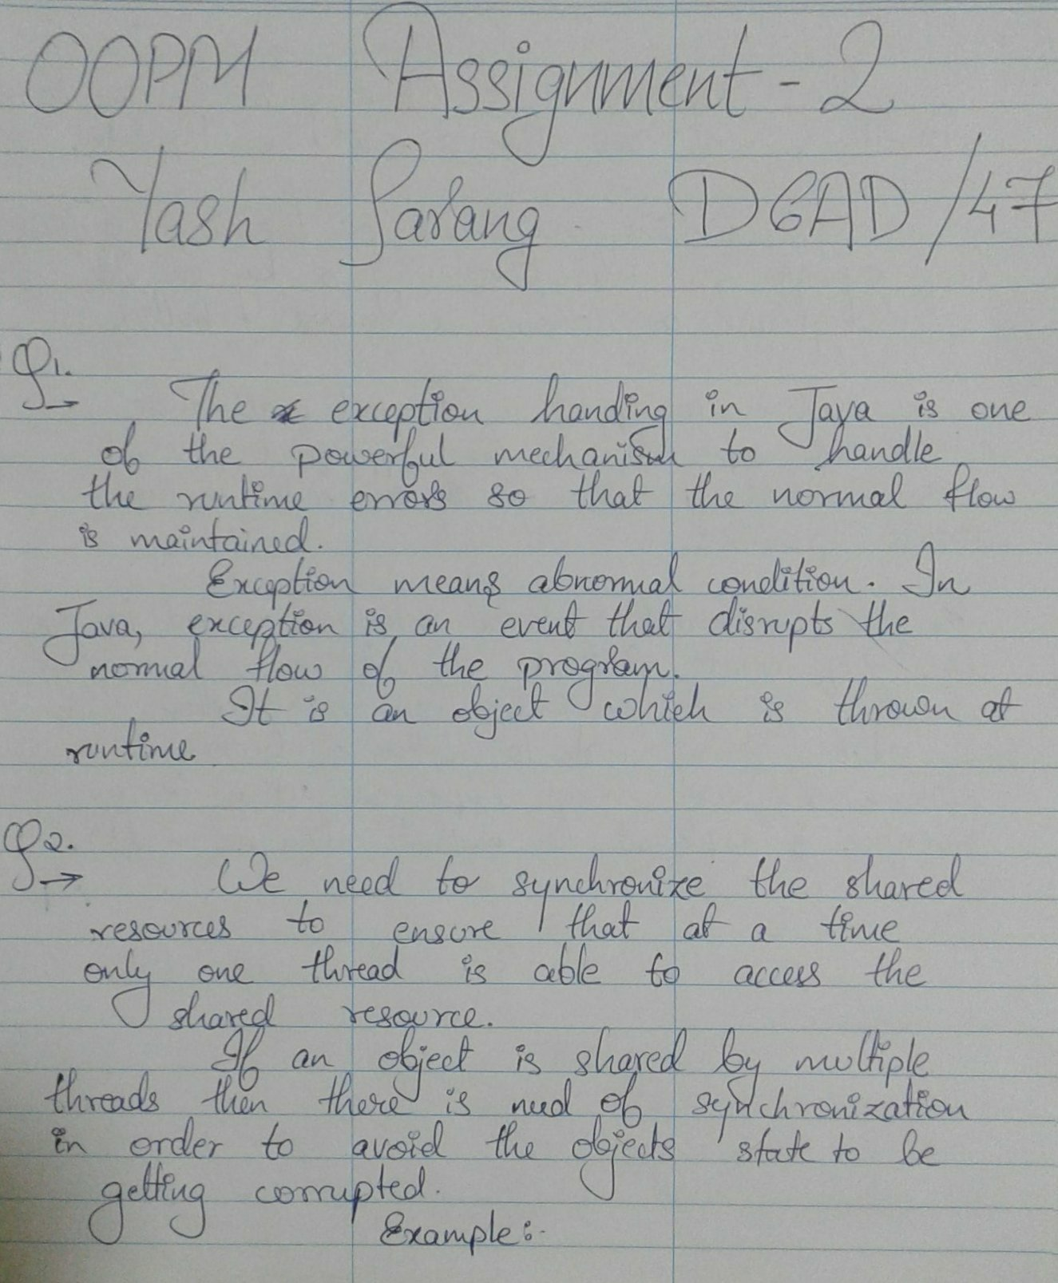

***Non Synchronized Code:***

*class Table {*

*void printTable(int n) { //method not synchronized*

*for (int i = 1; i <= 5; i++) {*

*System.out.println(n * i);*

*try {*

*Thread.sleep(400);*

*} catch (Exception e) {*

*System.out.println(e);*

*}*

*}*

*}*

*}*

*class MyThread1 extends Thread {*

*Table t;*

*MyThread1(Table t) {*

*this.t = t;*

*}*

*public void run() {*

*t.printTable(5);*

*}*

*}*

*class MyThread2 extends Thread {*

*Table t;*

*MyThread2(Table t) {*

*this.t = t;*

*}*

*public void run() {*

*t.printTable(100);*

*}*

*}*

*class TestSynchronization1 {*

*public static void main(String args[]) {*

*Table obj = new Table(); //only one object*

*MyThread1 t1 = new MyThread1(obj);*

*MyThread2 t2 = new MyThread2(obj);*

*t1.start();*

*t2.start();*

*}*

*}*

***OUTPUT:***

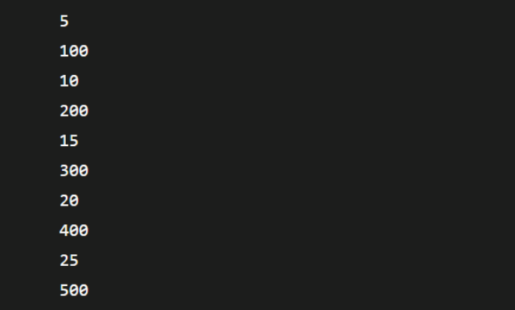

***Synchronized Code: -***

*class Table {*

*synchronized void printTable(int n) { //synchronized method*

*for (int i = 1; i <= 5; i++) {*

*System.out.println(n * i);*

*try {*

*Thread.sleep(400);*

*} catch (Exception e) {*

*System.out.println(e);*

*}*

*}*

*}*

*}*

*class MyThread1 extends Thread {*

*Table t;*

*MyThread1(Table t) {*

*this.t = t;*

*}*

*public void run() {*

*t.printTable(5);*

*}*

*}*

*class MyThread2 extends Thread {*

*Table t;*

*MyThread2(Table t) {*

*this.t = t;*

*}*

*public void run() {*

*t.printTable(100);*

*}*

*}*

*public class TestSynchronization2 {*

*public static void main(String args[]) {*

*Table obj = new Table(); //only one object*

*MyThread1 t1 = new MyThread1(obj);*

*MyThread2 t2 = new MyThread2(obj);*

*t1.start();*

*t2.start();*

*}*

*}*

***OUTPUT:***

